**C868 – Software Capstone Project Summary**

**Task 2 – Section C**

|  |  |
| --- | --- |
| **Capstone Proposal Project Name:** | http://www.idevnews.com/views/images/uploads/general/wgu_logo.png  Music Lesson Scheduler |
| **Student Name:** | Dean Kelly |

**Table of Contents**

Contents

Table of Contents 2

Task 2 Part C – C868 Software Development Capstone 4

Application Design and Testing 4

Design Document 4

Class Design 4

UI Design 5

Unit Test Plan 6

Introduction 6

Purpose 6

Overview 6

Test Plan 6

Items 6

Features 6

Deliverables 6

Tasks 6

Needs 7

Pass/Fail Criteria 7

Specifications 7

Procedures 8

Results 8

C4. Source Code 8

User Guide 9

Introduction 9

*Login* 9

*Students* 9

*Add a new student* 9

View a student. 10

Delete a student. 10

Edit a student. 10

*Lessons* 11

*Add a new lesson* 11

View a lesson/share lesson note. 11

Delete a lesson. 11

Edit a lesson. 12

Task 2 Part C – C868 Software Development Capstone

# Application Design and Testing

# Design Document

## Class Design

The music lesson scheduling mobile application consists of two classes, the Student class and the Lesson class. The Student class contains StudentID,StudentName, StudentPhone, StudentEmail, StudentSkillLevel, and StudentInstrument. The Lesson Class contains LessonID, LessonName, LessonDate, LessonTime, LessonReminder, LessonNotes, and StudentID. StudentID is the primary key for the Student class and the foreign key for the Lesson class. The following diagram provides a visual representation of both classes.

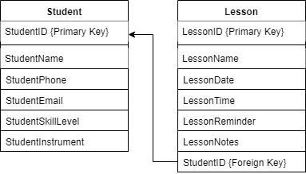

## UI Design

The User Interface Design is represented here with a high-fidelity mockup. The mockup displays each page of the application. The color scheme, layout, and text remained consistent with what was ultimately implemented in the final design of the application.

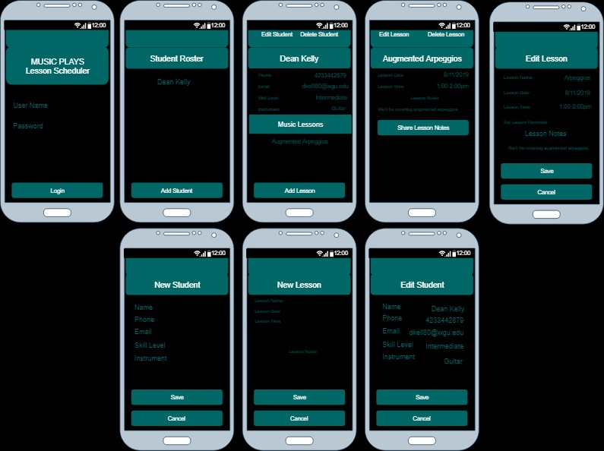

# Unit Test Plan

## Introduction

### Purpose

The purpose of this test case is to ensure the functionality of the login screen and ensure the security of the application.

### Overview

The login screen was tested by first clicking the login button without entering anything. Then the login screen was tested by entering the incorrect username and password and clicking the login button. Finally, the correct username and password were entered, and the login button was clicked. The test was to ensure that the login screen would present an error message if the incorrect username and password were entered or if both were left blank. The test also checked to ensure that the correct username and password allowed entry into the application.

## Test Plan

### Items

A valid username and password.

### Features

Login functionality, prevention of null values, and a message alerting of invalid entries.

### Deliverables

The test resulted in documentation that included screenshots.

### Tasks

The user would click the login button without entering a username or password.

The user would click the login button after entering an incorrect username and password.

The user would click the login button after entering the correct username and password.

### Needs

The test required Visual Studio with Xamarin Forms and SQLite along with an Android emulator.

### Pass/Fail Criteria

The test passed if the correct username and password granted the user access to the application. The test also passed if the incorrect username and password or lack of username and password denied access and resulted in a message box advising the user of an invalid entry and prompting them to try again.

The test failed if incorrect usernames and passwords or blank entries still allowed the user entry into the application. The test also failed if the user would be denied access after entering the correct username and password.

## Specifications

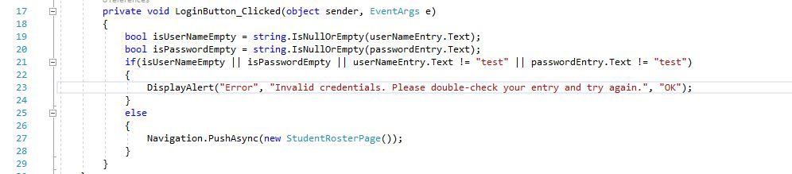

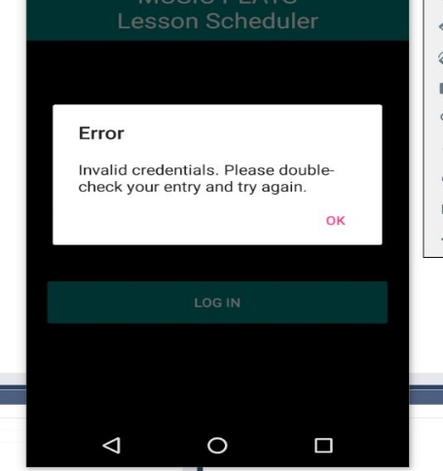

## Procedures

1. The user enters the correct username and password.
2. The user clicks the login button.
3. The user restarts the application.
4. The user clicks the login button without entering anything.
5. The user restarts the application.
6. The user enters an incorrect username and password.
7. The user clicks the login button.

## Results

Here is the code that ensured only access was granted after entering the correct name and password. The screenshot to the right shows the message that is presented to the user if an incorrect or blank entry is made.

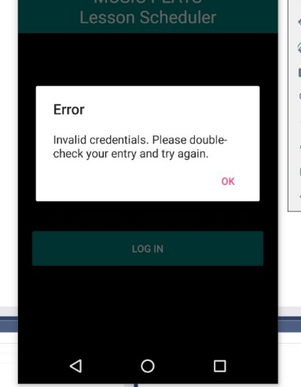

# C4. Source Code

Please see the attached zip file to view the source code and access the fully functioning application. The username is “test” and the password is also “test”.

# User Guide

## Introduction

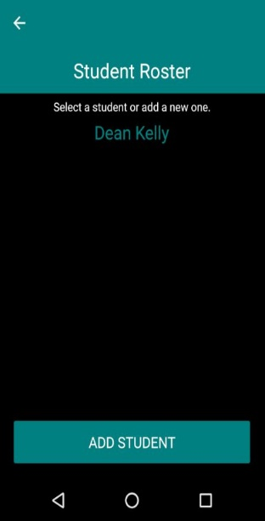This guide will explain each step the user must take in order to use this application successfully. These steps will include logging in to the application, adding, viewing, editing, and removing students as well as adding, viewing, editing, and removing lessons.

## *Login*

1. *First, touch User Name and enter a valid username.*
2. *Next, touch Password and enter a valid password.*
3. *Finally, click the Login button to load the Student Roster page.*

## *Students*

### *Add a new student*

1. *Once logged in, you will be presented with the student roster page. Click on the button labeled “Add Student” which will load the add student page.*
2. *Enter the student’s name, phone number, email address, skill level, and instrument.*
3. *Click “Save” to add the student, otherwise click “Cancel” or the back button to cancel adding the student.*

### View a student.

1. *Select a student from the student roster to load that student’s detail page.*
2. *The student detail page will display student information and scheduled music lessons for that student.*

### Delete a student.

1. *Select a student from the student roster that you would like to delete.*
2. *Click “Delete Student” from the top right corner of the student detail page to delete the student from the application.*

### Edit a student.

1. 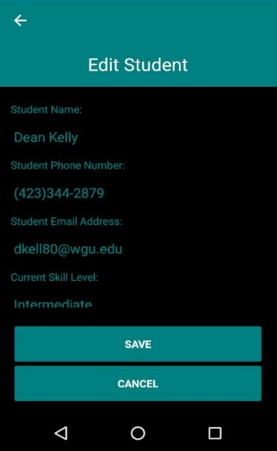*Select a student from the student roster.*
2. *Click “Edit Student” from the top left of the student detail screen to navigate to the edit student page.*
3. *Select any fields to update and change the entry.*
4. *Click “Save” to update the student information or “Cancel” to abandon any changes and return to the student detail page.*

## *Lessons*

### *Add a new lesson*

1. *Select a student from the student roster.*
2. *Click “Add Lesson” at the bottom of the student detail page.*
3. *Enter the Lesson Name, Lesson Date, and Lesson Time.*
4. *Set Lesson Reminder to get a notification prior to the lesson.*
5. *Enter Lesson Notes.*
6. *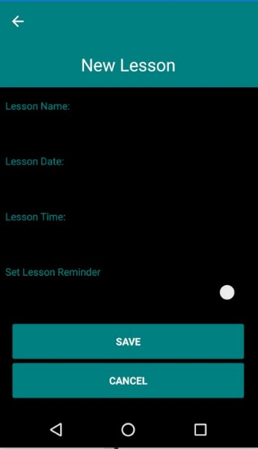Click “Save” to add the lesson, otherwise click “Cancel” or the back button to cancel adding the lesson.*

### View a lesson/share lesson note.

1. *Select a student from the student roster.*
2. *Select a lesson from the student detail page.*
3. *View all lesson details from the lesson detail page.*
4. *Click “Share Notes” to share the Lesson Notes.*

### Delete a lesson.

1. *Select a student from the student roster.*
2. *Select a lesson from the student detail page.*
3. *Click “Delete Lesson” from the top right corner of the lesson detail page to delete the lesson from the application.*

### Edit a lesson.

1. *Select a student from the student roster page.*
2. *Select a lesson from the student detail page.*
3. *Click “Edit Lesson” from the top left of the lesson detail screen to navigate to the edit lesson page.*
4. *Select any fields you want to update and change the entry.*
5. *Click “Save” to update the lesson information or “Cancel” to abandon any changes and return to the lesson detail page.*